**PIZZA SALES QUERIES**

A.KPI’s

**1. Total Revenue:**

SELECT SUM(total_price) AS Total_Revenue FROM pizza_sales;

***Output:***

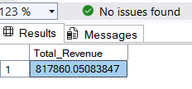

**2. Average Order Value**

select SUM(total_price)/COUNT(DISTINCT order_id) AS Avg_Order_Value FROM pizza_sales

***Output:***

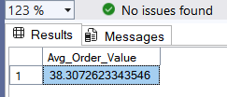

**3. Total Pizzas Sold**

select SUM(quantity) AS Total_Pizza_Sold FROM pizza_sales

***Output:***

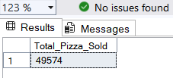

**4. Total Orders**

select COUNT(DISTINCT order_id) AS Total_Orders FROM pizza_sales

***Output:***

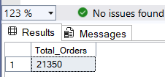

**5. Average Pizzas Per Order**

SELECT CAST(CAST(SUM(quantity) AS DECIMAL(10,2)) /

CAST(COUNT(DISTINCT order_id) AS DECIMAL(10,2)) AS DECIMAL(10,2))

AS Avg_Pizzas_per_order FROM pizza_sales

***Output:***

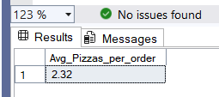

**B. Daily Trend for Total Orders**

select DATENAME(DW,order_date) as Order_Day, COUNT(DISTINCT order_id) as Total_Orders from pizza_sales

GROUP BY DATENAME(DW,order_date) ;

***Output:***

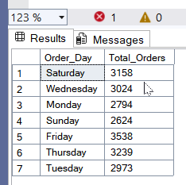

**C. Hourly Trend for Orders**

select DATEPART(HOUR, order_time) AS order_hours,COUNT(DISTINCT order_id) as Total_Orders from pizza_sales

GROUP BY DATEPART(HOUR, order_time)

ORDER BY DATEPART(HOUR, order_time);

***Output:***

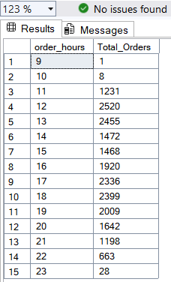

**D. % of Sales by Pizza Category**

select pizza_category,SUM(total_price)*100/(select SUM(total_price)from pizza_sales) as PCT_of_Total_sales

from pizza_sales group by pizza_category;

***Output:***

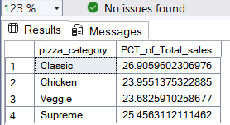

**E. % of Sales by Pizza Size**

select pizza_size,CAST(sum(total_price) AS DECIMAL(10,2)) as total_sales,CAST(SUM(total_price)*100/(select SUM(total_price)

from pizza_sales) AS DECIMAL(10,2)) AS PCT_of_Total_sales from pizza_sales group by pizza_size

order by PCT_of_Total_sales DESC ;

***Output:***

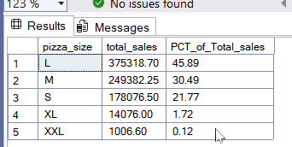

**F. Total Pizzas Sold by Pizza Category**

select pizza_category,sum(quantity) AS Total_Pizza_sold

from pizza_sales group by pizza_category ;

***Output:***

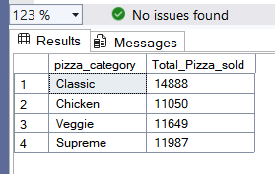

**G. Top 5 Best Sellers by Total Pizzas Sold**

select TOP 5 pizza_name,SUM(quantity) as total_pizza_sold

from pizza_sales

group by pizza_name

order by SUM(quantity) DESC

***Output:***

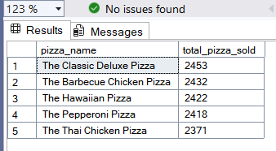

**H. Bottom 5 Best Sellers by Total Pizzas Sold**

select TOP 5 pizza_name,SUM(quantity) as total_pizza_sold

from pizza_sales

group by pizza_name order by SUM(quantity) asc

***Output***

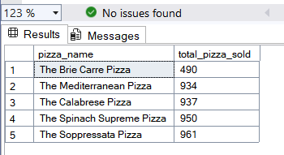

***NOTE***

If you want to apply the Month, Quarter, Week filters to the above queries you can use WHERE clause. Follow some of below examples

SELECT DATENAME(DW, order_date) AS order_day, COUNT(DISTINCT order_id) AS total_orders

FROM pizza_sales

WHERE MONTH(order_date) = 1

GROUP BY DATENAME(DW, order_date)

*\*Here MONTH(order_date) = 1 indicates that the output is for the month of January. MONTH(order_date) = 4 indicates output for Month of April.*

SELECT DATENAME(DW, order_date) AS order_day, COUNT(DISTINCT order_id) AS total_orders

FROM pizza_sales

WHERE DATEPART(QUARTER, order_date) = 1

GROUP BY DATENAME(DW, order_date)

*\*Here DATEPART(QUARTER, order_date) = 1 indicates that the output is for the Quarter 1. MONTH(order_date) = 3 indicates output for Quarter 3.*